# Run time results Dashboard

## 1. Introduction

“Dashboard” is a feature of ZenQ’s Selenium test framework with intention to provide run time results during the execution of test scripts. User can see individual status of each test under execution and also summary of all test scripts after the execution.

## 2. Launching the dashboard

Please follow the steps below to launch the dashboard

1. Double click on ‘Ant_Build.bat’ or ‘ant.sh’file from project folder to kick-off the automated tests setup.

2. After Execution starts, open ‘/Dashboard/index.html’ file in another window of Firefox browser (currently this feature supports “Firefox” browser only). The dashboard automatically shows the number of tests to execute under “Total No.of Scripts” column. This number is same as number of tests you’ve defined in TestNG.xml.

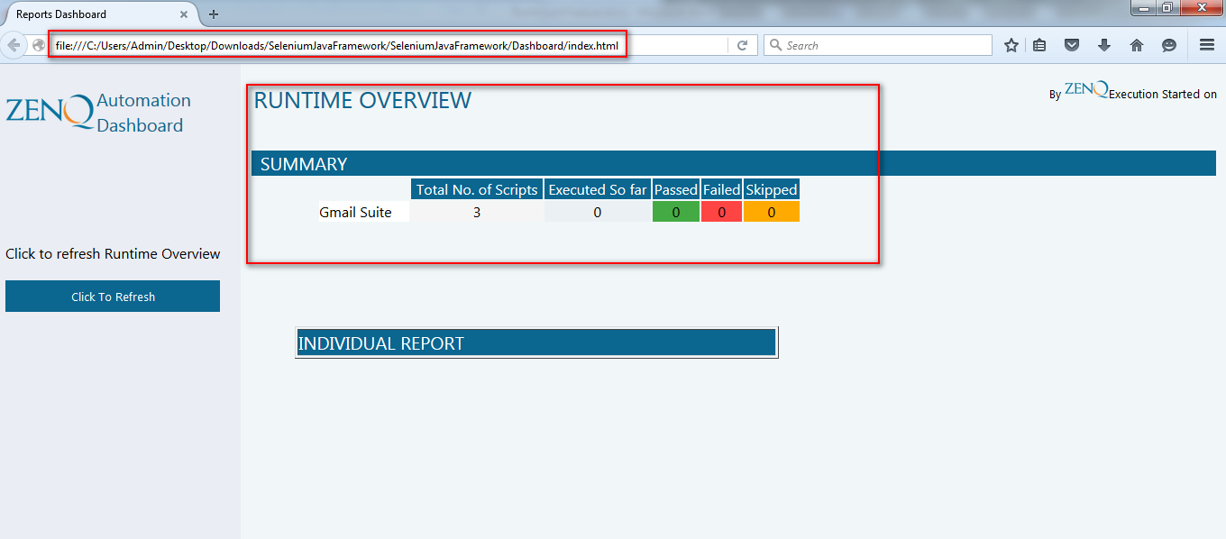

3. As the tests are getting executed, click “Click to Refresh” button to get the latest statistics on number of test passed, failed and skipped along with test name under “Individual report” section.

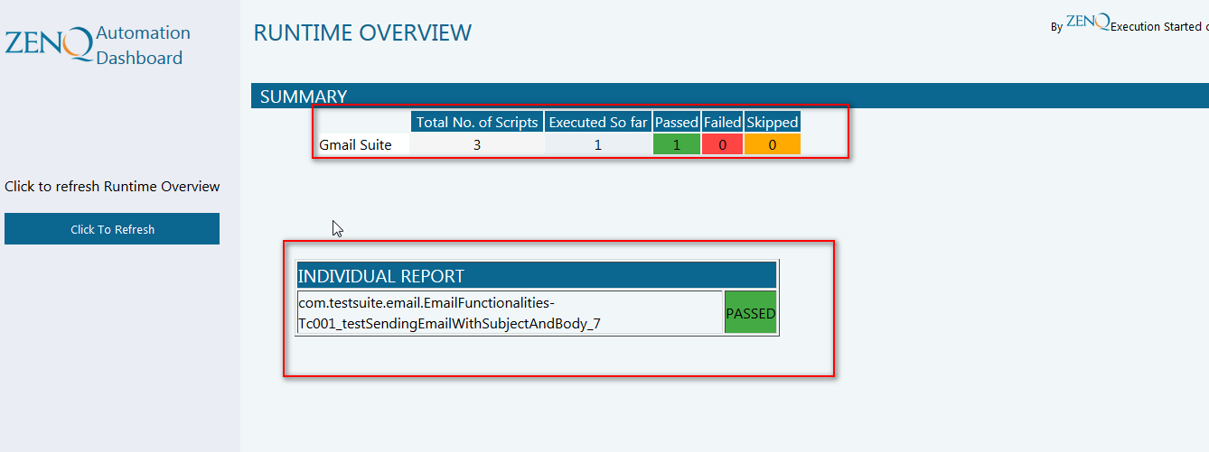

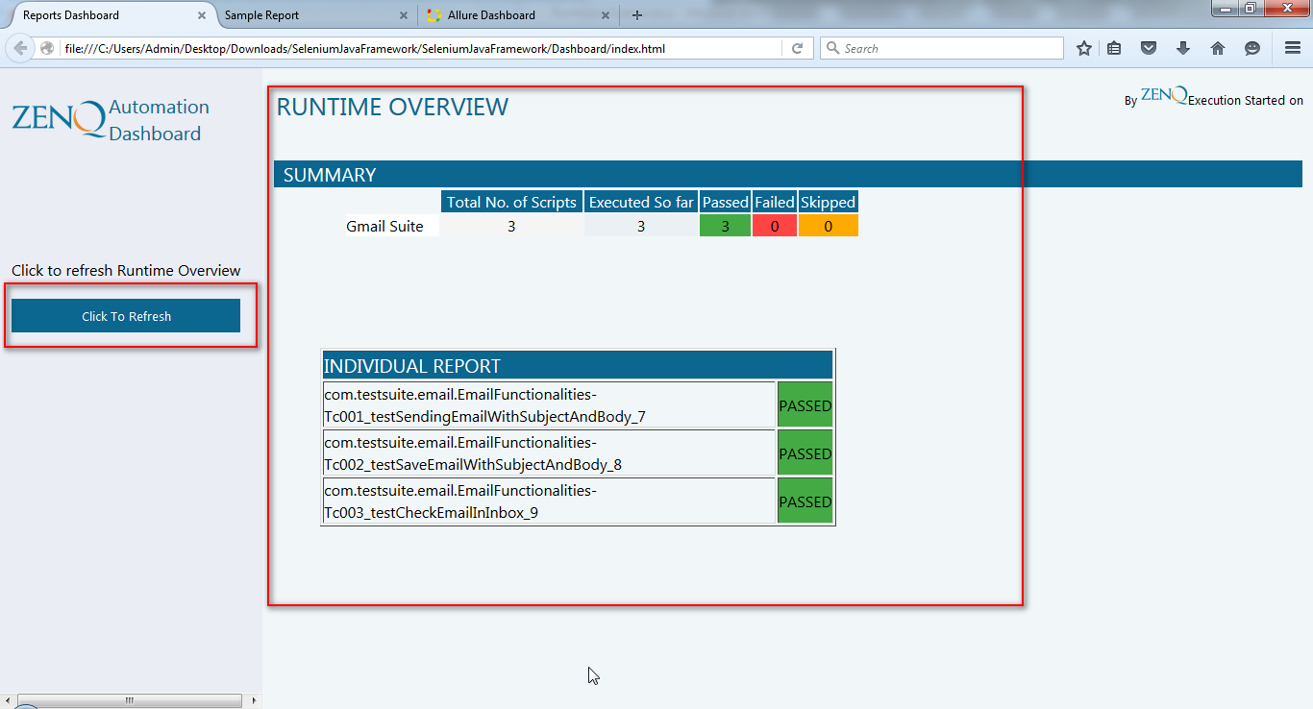

4. Once all tests are executed, the following popup will appear indicating that the execution is completed. By this time, reports should’ve been launched automatically in another browser tab/window (if you’ve run the tests using ant.bat or ant.sh)

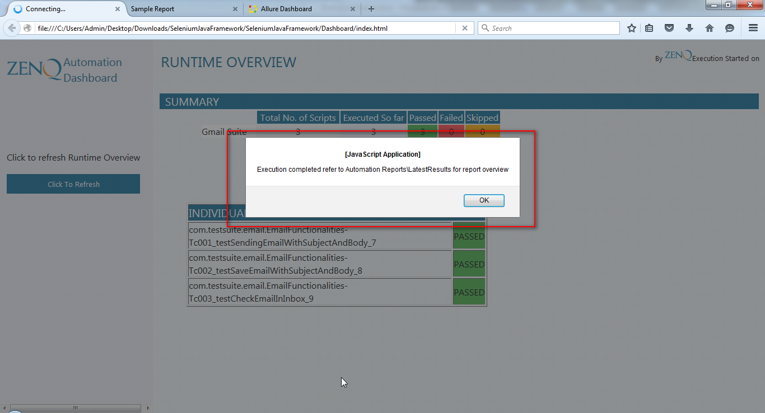

## 3. Customization

To make any additional changes to the existing behavior of the code, please open “dashboard.js” file from the following location.

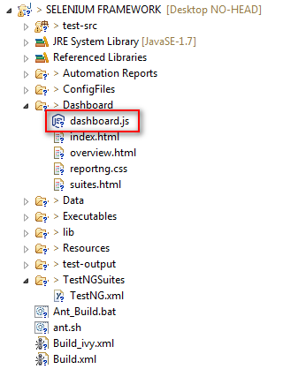

This feature works in similar way with selenium grid, sauce labs etc. However, this feature currently doesn’t support test cases which has Data provider, i.e. statistics on the dashboard with data provider test may appear incorrectly.